A-Z Higher Study in Abroad: New Approach

Nowadays, Students are creating quality, meaningful, successive carrier & future via Higher Study. The number of students is increasing, studying at a reputable university abroad to the imminent goal. While planning to pursue study abroad, one must know what to look for and where, and decide accordingly on their next moves. You need to properly maintain work efficiently throughout your entire application process. Some considerations are

# Why Go Abroad

Share Knowledge & Skills



Research & Technology

International Degree

Connections Worldwide

Students Experiences

To Aquire Quality Education

Career Opportunities

Find New Interests

Culture Take in a New

See the World

Make Lifelong Friends

Personal Development

Contribution to Own Country (Experience, Knowledge, Extension of Education ).

# Where to Go

According to the opportunities, ranking, funding, social security, research interest, etc. of the

University and their admission requirement classify with International students-

1. United States of America(740482)
2. Australia(249588) , Canada(120960)
3. New Zealand, United Kingdom, France
4. Japan(150617), Sweden, Netherlands(57509), Finland, Poland, Ireland
5. Germany(206976), Taiwan, Malaysia(63625), Italy(77732), Norway, Switzerland VI. China(88979), Turkey, South Korea, Austria(58056), India

# How to filter University

1. Research Interest
   * Research Specific Ranking
   * Professor’s Profile
   * Research Outreach
   * Grant Availability
2. Funding Opportunity
   * Networking
   * Research Expenditure
3. Ranking
   * Field Specific
   * Quality of Education
   * Quality of Research
4. Job Prospect
   * Area Specific
   * Career Fair
   * Internship
5. Brand
   * Alumni Connection
   * Exposure
6. Expense
   * Tuition Fees
   * Living Expense
7. Location
   * Climate
   * Settlement
   * Resident-ship ✓ Living Standard

# Requirement & Qualification

1. Personal info
   * Passport
   * Photograph
   * CV
   * Statement of Purpose (SOP)
2. Academic Info Transcript



Certificate

1. Work Experience (Not Mandatory)
   * Job Certificate
   * Internship
   * Project
2. Test Scores IELTS / TOEFL



GRE / GMAT

1. Recommendation of Letters (LOR)
2. Research Experiences

Publications



Poster Presentations

Research Proposal

1. Financial Info Bank Statement



Affidavit of Support

Scholarship & Funding

1. Extra curriculum Activities ( Not Mandatory )

Debating



Seminar

Leadership Program

Volunteering & Social Work Article Writing etc.

# Curriculum Vitae

* Not copy / paste
* Should be academic & informative
* Specific

# CGPA ( Both Undergraduate & Graduate )

* Minimum 60 % mark require (3.0)
* Good (3.50)
* Require high CGPA in Australia

# GRE - Graduate Record Examination

* Analytical Writing: 2 tasks, 1 hr (score: 0-6 )
* Verbal Reasoning: 2 sections, 1 hour (Score: 140-170 )
* Quant Reasoning : 2 sections , 70 min (score : 140-170 )
* Total score : 340 & 6
* Validity: 5 years
* Mostly for USA , CANADA(only some University ) • Above 300 +4 scores good for funding.

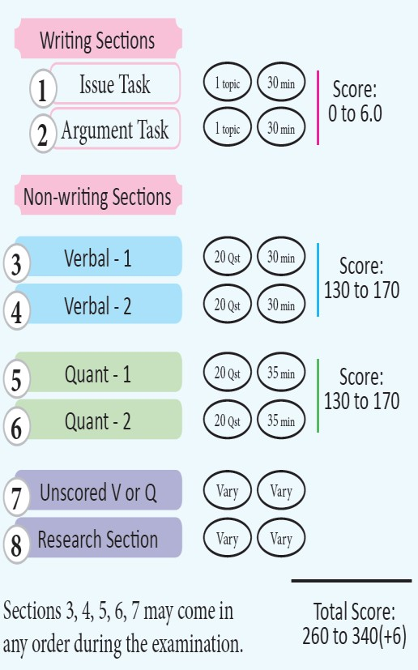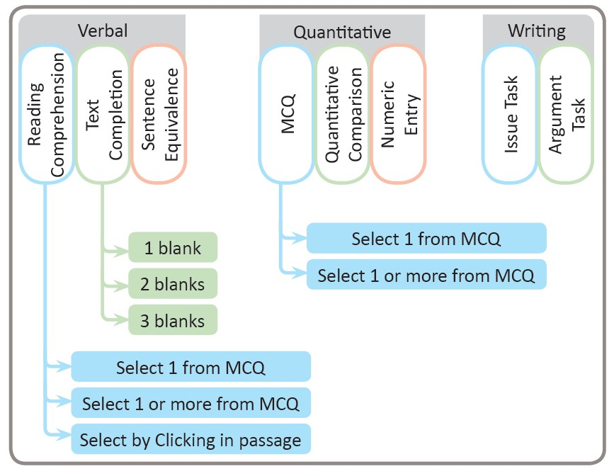

* Book List
  + Verbal section: Magoosh 1000 words, Word smart 1 & 2, Vocabuilder, Manhattan 5 lb, ETS official verbal Reasoning-practice questions
  + Quantitative section: Nova’s Math Bible, Manhattan GRE 1-6 & 5 lb, ETS official
  + Analytical Writing Section: ETS official
* For more information:<http://hsa.grecbd.com/>

# GMAT – Graduate Management Admission Test

* Analytical Writing: 1 topic, 30 min (score :0- 6 )
* Integrated Reasoning : 12 questions , 30 min , (Score : 0-8 ) 4 types questions
  + Table analysis
  + Graphics Interpretation
  + Multi-source Reasoning
  + Two-Part Analysis
* Verbal Reasoning : 41 questions, 75 min ( score : 0-60 ), 3 types
  + Reading Comprehension
  + Sentence Correction
  + Critical Reasoning
* Quant Reasoning : 37 questions, 75 min (score : 0-60 ), 2 types
  + Problem Solving
  + Data Sufficiency
* Total Score : 800 & 6
* Validity: 5 years
* Mostly for USA , CANADA(only some University )
* Book List
  + Verbal: Manhattan Sentence Correction Guide, Powerscore Critical Reasoning Bible, The Official Guide for GMAT Review, 2015.
  + Quant: Manhattan Quant Strategy Guide, Veritas Guide
  + AWA + Integral: Online
  + For more book & book list:<http://hsa.grecbd.com/downloadvault/>
* For More Information
  + GMAT facebook group:

<https://www.facebook.com/groups/gmat.bd/750648114952641/> Youtube:

[https://www.youtube.com/watch?v=Wi9yTU4Jpmo&index=2&list=PLV3FbbK1](https://www.youtube.com/watch?v=Wi9yTU4Jpmo&index=2&list=PLV3FbbK10cfv5cNXEHHbCMfQZL0pV3eoV)

[0cfv5cNXEHHbCMfQZL0pV3eoV](https://www.youtube.com/watch?v=Wi9yTU4Jpmo&index=2&list=PLV3FbbK10cfv5cNXEHHbCMfQZL0pV3eoV)

* + <http://hsa.grecbd.com/dbabusiness-administration/>

# IELTS – International English Language Testing System

Reading : 3 sections, 60 min Listening: 4 sections, 30 min Speaking: 15 min approx. Writing: 2 tasks, 60 min



All individuals score: 9.0

Band Score: 9.0

Preferred In Europe, Australia, Canada, Also USA (70-80 % University) Validity: 2 years Book List :

* Cambridge IELTS Test Practice (1-10) series
* Cambridge Vocabulary for IELTS
* Collins Vocabulary for IELTS
* Cambridge Grammar For IELTS
* Kaplan IELTS
* Barron’s IELTS  Important Links-
* [https://www.youtube.com/playlist?list=PLFpDgRIuIfmDLuvBMZRQLgnid5rW GaoJA](https://www.youtube.com/playlist?list=PLFpDgRIuIfmDLuvBMZRQLgnid5rWGaoJA)
* <http://hsa.grecbd.com/ielts-model-test/>

# TOEFL – Test of English as a Foreign Language

Reading: 3-5 passages, 60-100 min



Listening: 4-6 lectures, 2-3 conversation, 60-90 min

Speaking: 2 in deep, 4 integers, 20 min

Writing: 1 integrated, 1 independent, 20+30 min

All individuals score: 30

Band Score: 120

Preferred In USA, Canada Validity: 2 years Book List :

* ETS Official guide for TOEFL – 4 th Ed.
* Barron’s TOEFL iBT – 14 th Ed. ✓ Kaplan TOEFL iBT – 2013 Ed.
* Software: ETS Official

# SOP – Statement of Purpose

* Personal evaluation of higher study Or a story about yourself, Why are you admit in that University.
* CV is your information but SOP describes this information.
* What you say-

Why higher study



Research Interest

Publication / Research Experience

Master’s / PhD

Job / Teaching Profession

Why that University, Department, Professor

Your Qualifications: Academic(result, class rank, class size), Research & Papers, Scholarship, Special software using, Semi curricular & noncurricular activities How could you fulfill their research, academic & others requirement What is the similarity of Professor & your work, etc.



Should be tidy up your information.

❖ Not to say-

That you give to CV (if not fact )



Emotion

Fairytale

Excess personal story

Your Country lacking research ability, low economy, safety, educational qualifications & others.

# LOR – Letter of Recommendation

* It is a reference letter of the third person (your well-known Professor) appraise to reck of your SOP.
* The transparent notion of you by this third person.
* IT helps to decide your admission in admission committee.
* 2/3 LOR needed
* Two types: Online & Offline
* Who gives you Professor



Project/research supervisor Your job senior officer

# Publications

* International certifying high impact factor research paper s helps to get a satisfied fund.
* Journal paper, Conference paper, Poster Presentation.
* Article Writing ability
* Work experience of a research project  Intern report.

# Scholarship & Fund

Three types of fund are

1. Department / University Fund
   1. Fellowship
      * High competitive,
      * The highest amount paid,
      * Needed overall better academics
   2. Tuition Fee Waiver
2. Professor Fund
   1. Research Assistantship (RA)
      * Covers Tuition & Living
      * Better than TA-ship
   2. Teaching Assistantship
      * Covers Tuition & Living

1. Scholarship Fund
   1. International
      * [Erasmus Mundus Masters](https://eacea.ec.europa.eu/…/libr…/scholarships-catalogue_en)
      * [Commonwealth Scholarship (UK) for Commonwealth countries' citizens](http://cscuk.dfid.gov.uk/apply/)
      * [Chevening](http://www.chevening.org/)  UK
      * [Fulbright Program for Foreign Students](https://foreign.fulbrightonline.org/about/applicants) USA
      * [Vanier Canada](http://www.vanier.gc.ca/en/home-accueil.html)
   2. Country-specific
      * USA
      * [Australia(](https://www.education.gov.au/research-training-program)RTP) & International Postgraduate Research Scholarships (IPRS) for MS and PhD.
      * [Canada](http://www.educanada.ca/) & For Post Doc: Banting Post Doctoral Fellowships. NSERC (National Science and Engineering Research Council of Canada) Fellowships for MS and Ph.D.
      * [New Zealand](ttps://www.govt.nz/browse/education/tertiary-education/scholarships-grants-and-awards/)
      * [Japan,](http://www.mext.go.jp/en/) Also, University of Tokyo Fellowships (100-150). Society for the Promotion of Science (JSPS) Fellowship for post-doctoral degree. ✓ Germany: DAAD Scholarship (German Academic Exchange

Service), Universität Leipzig – (BuildMoNa Scholarship for Ph.D. Students). For Post Doctoral Fellowships: Humboldt Research Fellowship (AvH).

* + - [Sweden:](https://studyinsweden.se/) SI Scholarship
    - Malaysia International Scholarship (MIS) for MS, Ph.D. and Post Doctorate.
    - [Netherlands](https://www.studyinholland.nl/scholarships)
    - [Ireland](http://research.ie/funding/goipg/?f=postgraduate)
    - Belgium: [VLIR scholarship in international masters](http://www.vliruos.be/scholarships)
    - South Korea: Korean Government Scholarship Programme (KGSP) for Undergraduate and Post Graduate Studies.
    - [Saudi Arabia](https://www.kaust.edu.sa/en/study/applying-to-kaust)

* 1. Others

<http://scholarship-positions.com/> [www.mastersportal.eu](http://www.mastersportal.eu/)  [www.phdsportal.eu](http://www.phdsportal.eu/)  [www.studyineurope.eu](http://www.studyineurope.eu/)  [http://www.offeredscholarships.com](http://www.offeredscholarships.com/)  <http://www.oas.org/en/scholarships/> <http://www.scholars4dev.com/>



# The puzzle of Higher Study

Lack of knowledge of the scope of the higher study.



Limitation of thinking

Lower score of IELTS / TOEFL

Lower score of GRE/GMAT Financial problem

# How to Solve this Puzzle

* Try a little bit
* Eagerness
* Stick to Higher Study Abroad
* Retaining good CGPA
* Increasing skill of English
* Attain IELTS: above 6.5 and TOEFL: 90-100
* Attain GRE: above 310 and GMAT: above 650
* Experiences on Job, Internship, Project work
* International high impact factor Paper
* Semi & Extra curriculum activities
* Building better skills in Computer ✓ Increasing communications skill
* Don’t panic & disappointing
* Touch with Time, Hard work, Patience.

# Reference

1. [https://www.theguardian.com/higher-education-network/blog/2014/jul/17/top-20countries-international-students](https://www.theguardian.com/higher-education-network/blog/2014/jul/17/top-20-countries-international-students)
2. <http://hsa.grecbd.com/>
3. <http://shikkhok.com/>

Md. Faridul Islam (*Farid )*

Mawlana Bhashani Science and Technology University

Santosh, Tangail-1902, Bangladesh.